Ex 1.

Reaksmey Rin

1. This program will print the event number.
2. The program asking for the number then check if the number can divide with 2 without then it will print the number.

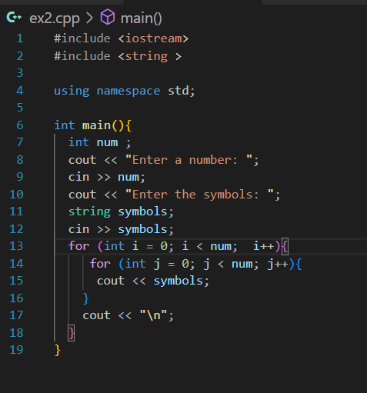Ex 2.

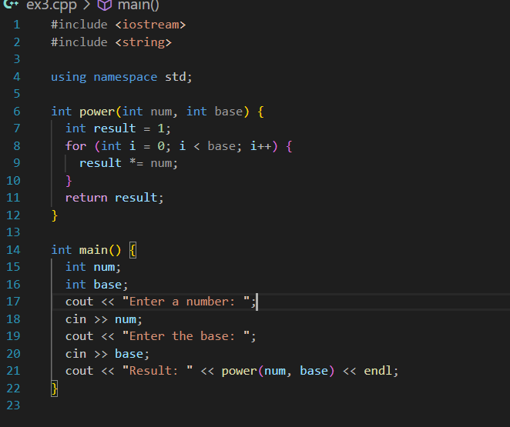Ex3.

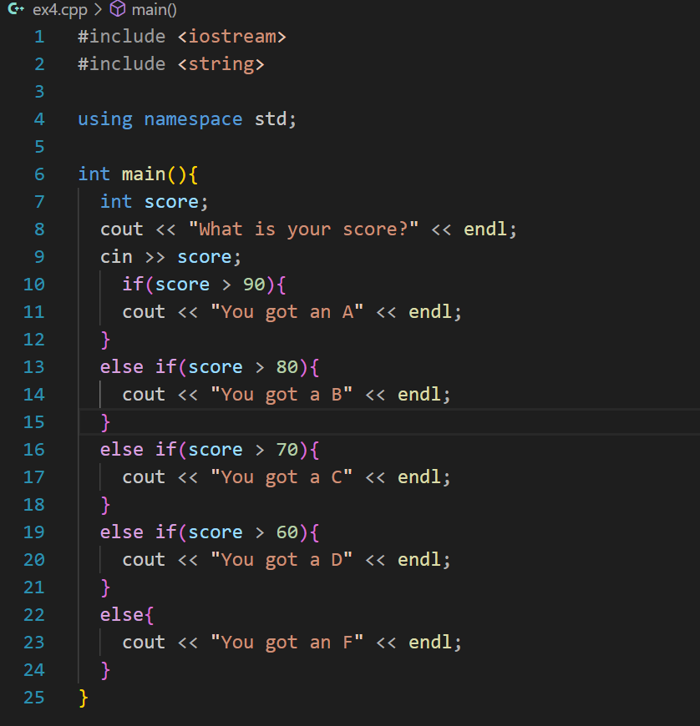Ex4

Ex 5

1. This code calculates the sum of the digits of the number entered by the user and then outputs that sum.

2.For example if I put 123 it gonna output Initialization:

num = 123

sum = 0

t = 123

First Iteration:

Iteration 1:

num = 123

r = 123 % 10 = 3

sum = 0 + 3 = 3

After the first iteration:

num = 12

sum = 3

Second Iteration:

Iteration 2:

num = 12

r = 12 % 10 = 2

sum = 3 + 2 = 5

After the second iteration:

num = 1

sum = 5

Third Iteration:

Iteration 3:

num = 1

r = 1 % 10 = 1

sum = 5 + 1 = 6

After the third iteration:

num = 0

sum = 6

Loop Termination:

Since num is now 0, the loop terminates.

Output:

The loop has finished executing. The program prints 6.

Ex.6

1. This code will output the result of raise to the power by the terms number you enter.

For example, if u enter 2. It’s will output the number in order raise to the power of 2 and display the result one by one.